***CLIMATE CHANGE DISCUSSION BASED ON WORLD BANK DATA***

**Praveen**

**(Roll NO)**

This assessment is based on the manipulation of the world bank data for climate change. Several features have been compared between countries and years and different kind of plots like heatmap, line plot, bar chart and tables has been provided for easily visualizing the data.

[**Github**](http://www.github.com)

[DataSource](https://data.worldbank.org/topic/climate-change)

This discussion for the climate change were based on the data retrieved from 6 major countries along with several other attributes available in the data over selected years. The attributes selected includes population growth as base with agricultural land and electricity as compared over few years through modernizing. For the first analysis we will look into the renewable energy output vs consumption of the countries.

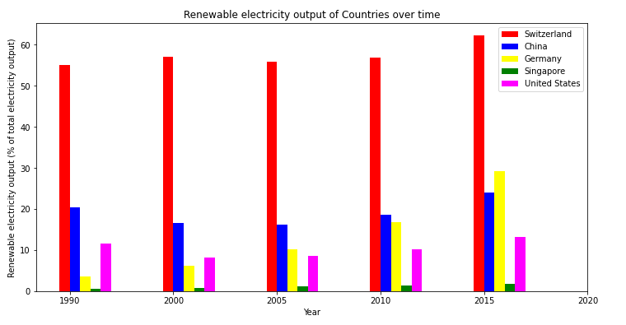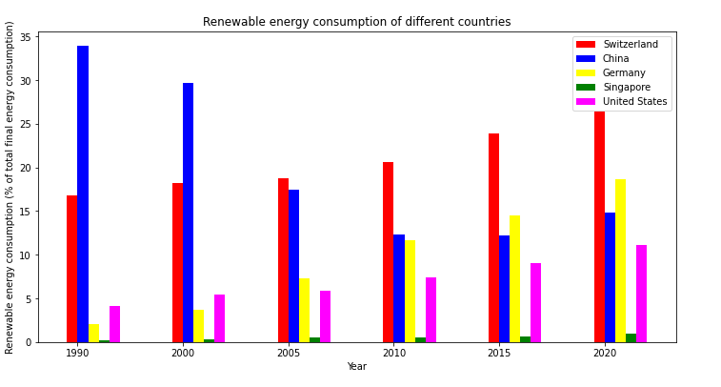

Based on the data, we can see that Switzerland produces more renewable energy (% of total output in a year) whereas it only consumes less of what it produces. They have more production than utilization. But in case of china, we can see the opposite, wherein it produces very little but uses more of it. This means they are in surplus of renewable energy. We can also see that china has reduced the usage within a period of 30 years and it is a steep reduction while its output is gradually increasing over years.

In the below table we can see the description of statistical data of Population Growth over years.

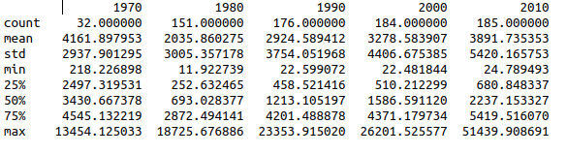

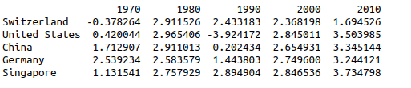

These were the population growth in % for different countries in different years that was used for summary description.

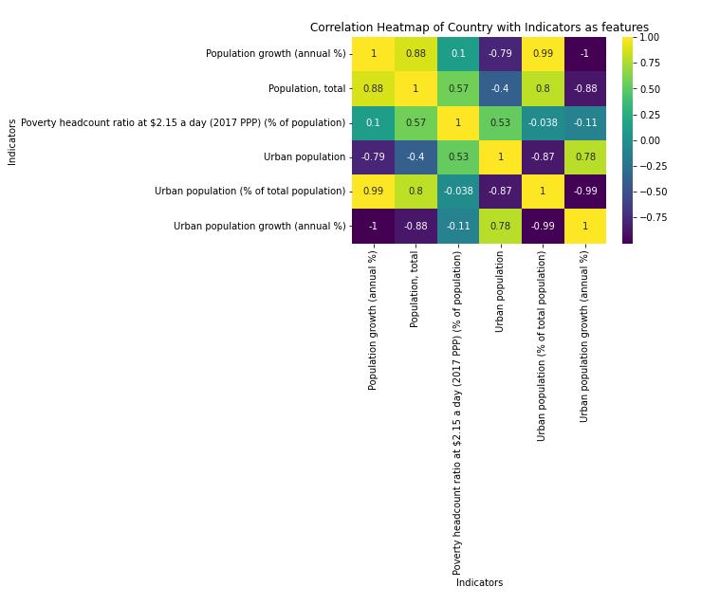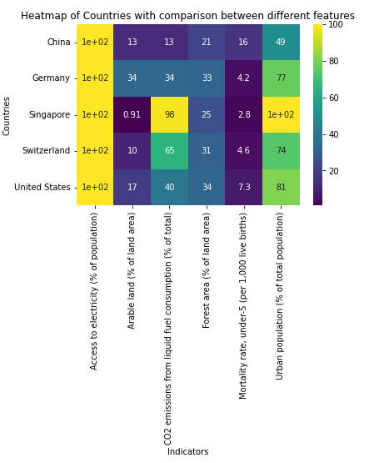

Now, lets look into the heatmap relation of countries based on the features. From the map we can see that more the urban population, less is the child mortality rate. This means that the urban population has less mortality than rural population. We can also see that china has less arable land and forest area compared to all other countries. But it has more rural population as the urban population is just 49 % of the total population. In the next map, we find the correlation heatmap of Australia. This shows us that the poverty headcount is positively proportional to the total and urban population of the country.

In the next plot, we will see the Electricity power consumption in KWh per capita of different countries through time.

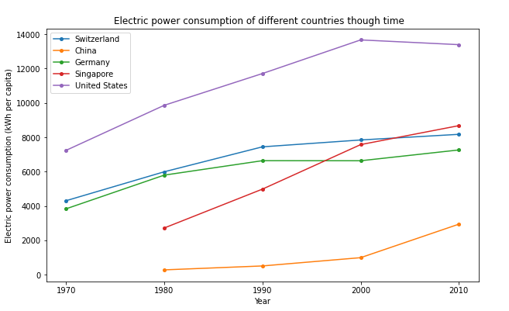

From this plot we can see that, Electricity of all selected countries has been gradually increasing over time period of 40 years. United states has reached its peak in 2000 and has been maintaining it till 2010. All the remaining countries has been over exploiting the power usage. This also explains the population growth of the countries which is directly proportional to the electricity consumption of individual.